**Markdown and Linux Exercise**

**Author - Rashmika Dineth Ruwanpathirana - BEIRP24A6**

**Part 1: Markdown exercise**

**Content**

* Introduction to Markdown
* Markdown syntax basics
* Introduction to Linux
* Basic commands

**Markdown examples**

* **This is a Bold text**
* *This is a italic text*
* [Assignment 4 - Link](https://github.com/Rashmika-Dineth/Linux/tree/main/Assignment%204)
* This can be a code block

| **No** | **Description** |
| --- | --- |
| 1 | Title |
| 2 | Text |
| 3 | Text |
| 4 | Text |

This is a Sample Image

[](https://github.com/Rashmika-Dineth/Linux/blob/main/Assignment%204/Images/image1.jpg)

**Part 2: Linux Exercise**

1. Open a Linux command prompt (terminal).

](https://github.com/Rashmika-Dineth/Linux/blob/main/Assignment%204/Images/2.png)

1. Create a new directory named markdown_linux_assignment with the command:

* mkdir markdown_linux_harjoitus
* Go to the created directory with the command: cd markdown_linux_harjoitus

The name **markdown_linux_harjoitus** used as the directory name

[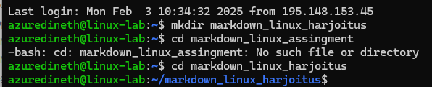](https://github.com/Rashmika-Dineth/Linux/blob/main/Assignment%204/Images/3.png)

1. Create a new empty file named README.md with the command:

* touch README.md

[](https://github.com/Rashmika-Dineth/Linux/blob/main/Assignment%204/Images/4.png)

1. Check that the file was created successfully with the command:

* ll

](https://github.com/Rashmika-Dineth/Linux/blob/main/Assignment%204/Images/5.png)

1. Open README.md file in a text editor, for example, using a nano editor:

* nano README.md

](https://github.com/Rashmika-Dineth/Linux/blob/main/Assignment%204/Images/7.png)

1. Add the existing Markdown content to the file and save the changes.

[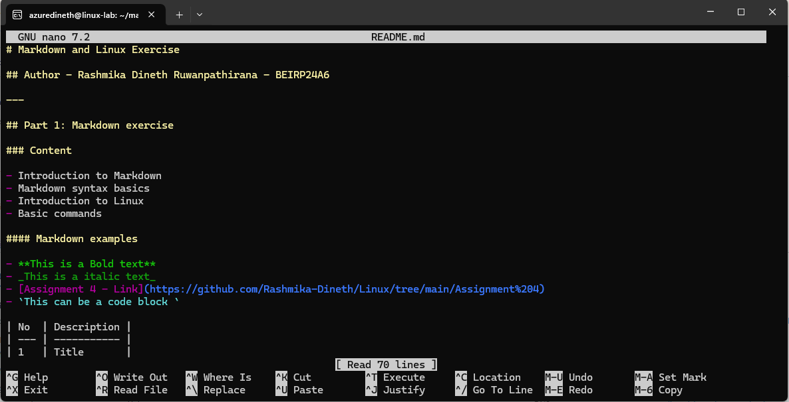](https://github.com/Rashmika-Dineth/Linux/blob/main/Assignment%204/Images/8.png)

**Part 3: Git version control**

1. Initialize a new Git repository in the directory with markdown_linux_assingment command:

* git init

](https://github.com/Rashmika-Dineth/Linux/blob/main/Assignment%204/Images/9.png)

1. Add README.md file to the Git repository with the command:

* git add README.md

[](https://github.com/Rashmika-Dineth/Linux/blob/main/Assignment%204/Images/10.png)

1. Make your first commit with the command:

* git commit -m "Initial commit: Added README.md with Markdown and Linux instructions"

](https://github.com/Rashmika-Dineth/Linux/blob/main/Assignment%204/Images/11.png)

**Task submission**

Return README.md file as an electronic version in the course learning environment. Return also the link to your own Git repository, pointing to file you created (.md).